INNER JOIN

Task Description:List User Name, Product Name, and Order Date for all placed orders.

SQL Query:
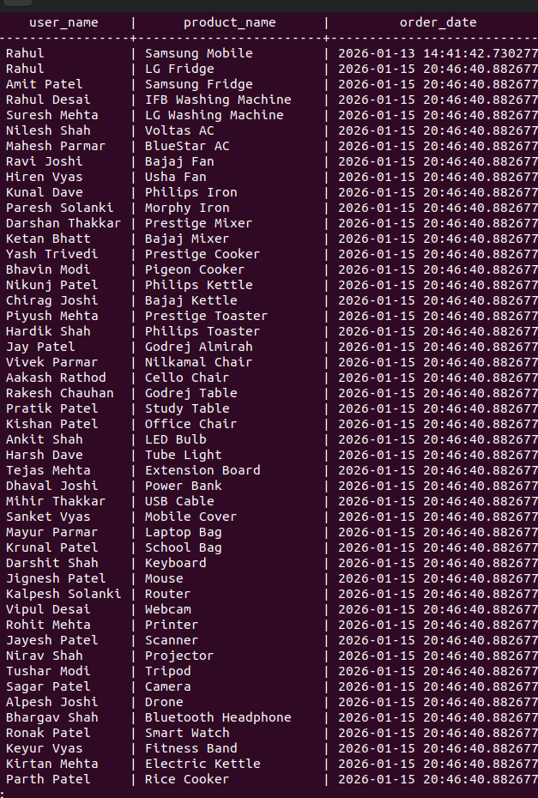
SELECT u.name AS user_name,p.product_name,o.order_date FROM orders o INNER JOIN users u ON o.user_id = u.user_id INNER JOIN order_items oi ON o.order_id = oi.order_id INNER JOIN products p ON oi.product_id = p.product_id;

Explanation:
The INNER JOIN retrieves only those records where matching data exists in all related tables. This query shows users who have placed orders along with the products they purchased.

LEFT JOIN

Task Description:
List all users and any products they have ordered.
If a user has not placed any order, product details should be NULL.

SQL Query:
SELECT u.name AS user_name,p.product_name FROM users u LEFT JOIN orders o ON u.user_id = o.user_id LEFT JOIN order_items oi ON o.order_id = oi.order_id LEFT JOIN products p ON oi.product_id = p.product_id;
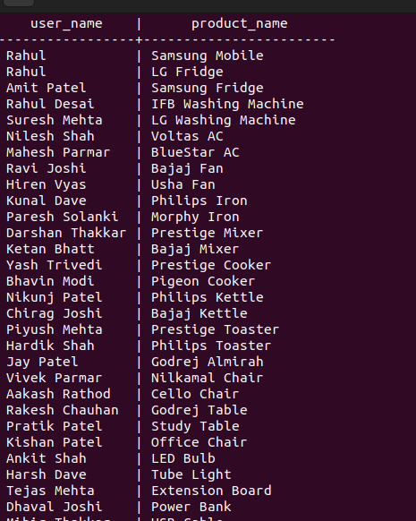

Explanation:
The LEFT JOIN returns all users, even those who have not placed any orders. If no matching order or product exists, the product columns show NULL values.

Task C: SELF JOIN (Bonus / Complex Join)

Task Description:
Find pairs of users who joined in the same year.

SQL Query:
SELECT u1.name AS user1, u2.name AS user2, EXTRACT(YEAR FROM u1.join_date) AS join_year
FROM users u1 INNER JOIN users u2ON EXTRACT(YEAR FROM u1.join_date) = EXTRACT(YEAR FROM u2.join_date) AND u1.user_id < u2.user_id;

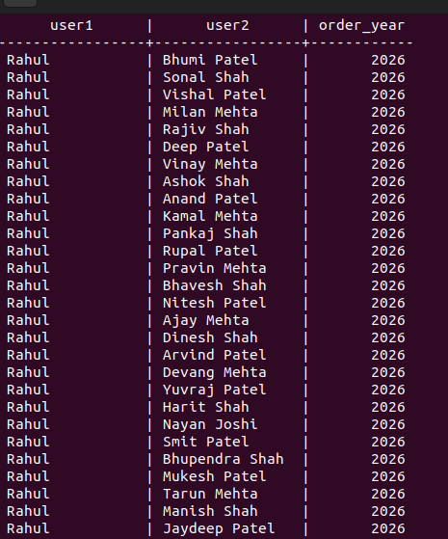

Explanation:
This SELF JOIN compares records within the same users table to find users who joined in the same year. The condition avoids duplicate and self-matching records.

